StrumTales Thoughts

Endorsers:
Joe Bonamassa
Rick Beato
Paul Davids
Rhet Shull

Guitar wall
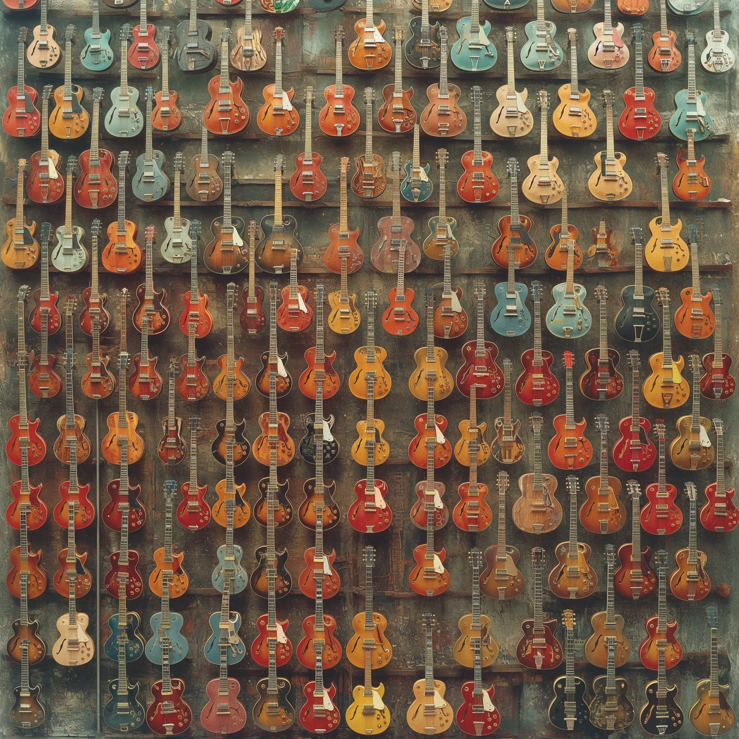

riff tales services:

PRICE GUIDE
The PRIVATE SHOWROOM / PUBLIC SHOWROOM options.
Dictionary
Blog
Network of Guitar techs: Identification and Authentication, Service,
Auctions

